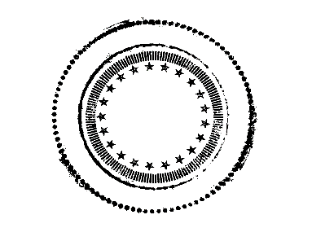
The Blue Octopus
Art Gallery | Champagne Bar
Beer / Cider
DRAFT
Stella Artois Belgian Pilsner…………………………………….…….....6
Sofie Saison, Farmhouse Ale……………………………………………..………...8
Rotating IPA, PALE ALE, STOUT, or HEFE…..….6-8
Mainly local, always awesome. Seasonal
BOTTLES + CANS
Goose Island ‘Matilda’ Belgian Style Pale
(12 oz Bottle)...………………………………………....….....5
Goose Island ‘Lolita’ American Wild Ale
(12 oz Bottle)………………..…………………....................….12
Ninkasi ‘Octoberfest”……………………………….….5
Uinta ‘Pumpkin’………………………………………..4
Matchless ‘OWL’(Old World Lager-Czech Pilsner)
(16oz Can)……………………………………………….7
Golden Road ‘Hollywood Blondie’ Pale Ale
(12 oz Can)…………………………….………………....…..4
10 Barrel Pub Beer Lager (12 oz Can)………………........3
Elysian Space Dust IPA (12 oz Can)…………….…...……4
Elysian Men’s Room Red (12 oz Bottle)………….……….4
Elysian Dayglow IPA (12 oz .Can)…………………....…...4
La Fin Du Monde Tripel (12 oz Bottle)…….……………………………………………...…...6
Köstritzer Schwarzbier Black Lager
(25 oz Can)…………………………………………………...5
1809 Berliner Style Weisse (25 oz Bottle).…................…..8
Kettle Sour
Miller High Life
Because…It’s The Champagne of Beer
(12 oz bottle).............................................................……4

CIDER
Stella Cidre (12 oz Bottle)………………………….......4
Original Sin ‘Black Widow’ Cider (12 oz Can)………..4 Blackberries, New York Apples + Champagne Yeast
Original Sin ‘Dry Rosé’ Cider (12oz Can)…...…….…..4
Grape Skins, New York Apples + Champagne Yeast
Portland Cider Company ‘Sangria’(16oz bottle).............8
Incline Hopped Cider (12oz can)……………………….……..4
Incline Marionberry Cider (12oz can)……………...………..4
Incline Seasonal Rotating Cider (12oz can)………....……..4
Duche De Longueville ‘Antoinette’ Cidre (750ml Bottle)…………………………...…………………….14
Lapinette ……………………………………………...12
(Norman-Style cidre brut, fermented with French yeast in French Oak. 750 ml Bottle)

SAKE
Poochi Poochi Sparkling Sake
Japan (330ml)…………………………...……………….…40
Kamaya Kyuzaemon
(with cedar cask aroma 300ml)………………………….....11

“I only drink Champagne on 2 occasions. When I am in love and when I am not.”
-Coco Chanel

