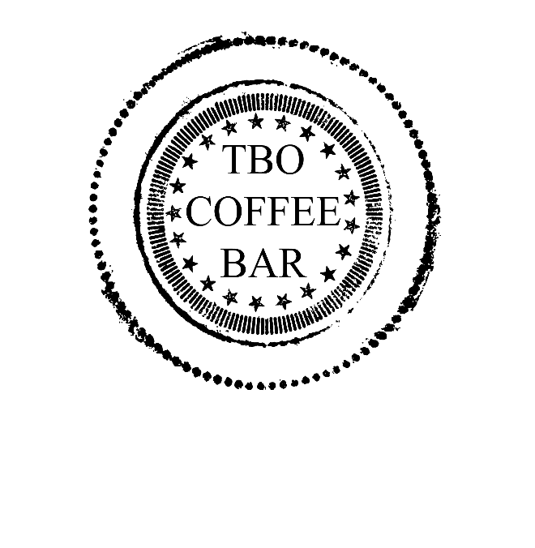
The Blue Octopus Coffee Bar

Freshly Baked Goods and Desserts from our kitchen, daily.
Locally Roasted Espresso Drinks and
Par Avion Tea

Baked Goods
Scones 4
Mixed Berry
Blueberry Lemon
Peanut Butter + Jelly
Vegan Gluten Free (variety)
Muffins 4
Blueberry
Raspberry
Almond Poppy Seed
Cinnamon Rolls 5
Cookies 3.50
Chocolate Chunk
White Chocolate Macadamia Nut
Oatmeal Raisin

Bars 4
Best Brownies Ever (no nuts, with chocolate ganache)
Lemon Bars
Mixed Berry

Cakes 5
Texas Sheet Cake
Better Than Sex Cake
Birthday Cake
Carrot Cake
GF Blueberry Almond Coconut

Desserts 8
NY Style Cheesecake
Flourless Chocolate Torte
Chocolate Mousse in Chocolate Cup
Swedish Cream with Raspberry Coulis in White Chocolate Cup
Pear Tart Tatin
4” Lemon Curd Tartlet

