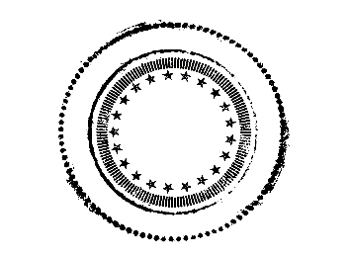

The Blue Octopus
Champagne Bar

Sparkling Cocktails
Ansel
12
Lemongrass syrup, lime and Prosecco combine to wake up your mouth.
His photos are in black and white, his namesake drink is a mouth full of color.
Frida
11
Pineapple, coconut and Prosecco with shredded organic coconut on the rim.
She would approve, so would the monkey.
Gritless
11
Prosecco with ginger beer and lime. Keeping Tacoma real, and gritty. But not real gritty.
Jackson
11
Guinness topped off with Prosecco.
Light vs Dark. The struggle is real.
Klimt
13
A beautiful ombré of blackberry simple syrup,
sparkling wine + a sprig of thyme tucked beneath a 24k gold dust rim.
Edible bling, Cheers, Gustav!
Leonardo
11
The ultimate classic. We've tinged an organic brown sugar cube from Mauritius with Angostura bitters (think grapefruit, not bitter at all) and topped it with a glass of Prosecco. Tried and true.

Monet
13
A beautiful, edible flower garden in glass pond of sparkling blue bubbles.
Art meets life and it is as delicious as pretty.
O’Keefe
11
A singular Hibiscus flower soaked in a rose water syrup, topped with Sparkling Wine.
As pretty as delicious. Go ahead, eat the flower (that's what she said).
Salvador
12
Enigmatic and refreshing. This cocktail gets a kick of heat form fresh, muddled jalapeño.
Not the kind of heat that melts clocks, still a little surreal and a lot delicious!
St. Germaine
12
Part Mystic, part Brut Champagne, Club Soda and organic Elderflower Syrup combine to create one of the best drinks in the world. According to us.
We think you'll agree. With a twist.
Vincent
12
Sparkling Rosé blushed with Blueberry & Lavender syrup from France, a kiss of grapefruit and a twist.
He would have loved it's tone and hue, then rinsed his brushes in it. Madman.
Zazel
10
We've placed a tuft of cotton candy atop a glass of bubbles. She was the first human cannonball. You go girl! #circuslife
* Make it a Unicorn, and we’ll add a Rainbow (candy stick) to your cotton candy cloud. Add $1.

“Champagne’s funny stuff. I’m used to whiskey. Whiskey is on the back, and champagne’s a heavy mist before my eyes.” -Jimmy Stewart

